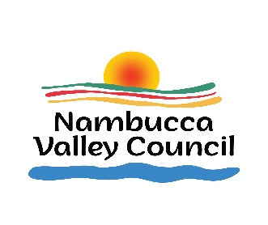
NAMBUCCA VALLEY COUNCIL

SECTION 356 DONATION PROGRAM

CHARITABLE ORGANISATIONS – WAIVER OF WASTE MANAGEMENT FEE

2024/2025 FINANCIAL YEAR

Name of applicant, organisation or group applying for waste management fee waiver:

Please tick one of the following:
_____ We currently have waiver of waste management fee status for 2023/2024 OR
_____ We are a new applicant

Street and postal address:

Contact name:

Telephone number:

Email address: _________________________________________________________

Description of organisation or group and confirmation of status as a charitable organisation: ________________________________________________________________________________________________________________________________________________________________________________________________________________________________________________________________________________________

Nature of waste to be disposed:
________________________________________________________________________________________________________________________________________________________________________________________________________________________________________________________________________________________

Estimated tonnage of waste to be disposed: ____________________ tonnes

PLEASE COMPLETE AND RETURN BY 24 MAY 2024 TO:
GENERAL MANAGER
NAMBUCCA VALLEY COUNCIL
PO BOX 177
MACKSVILLE NSW 2447

OR BY HAND:
44 PRINCESS STREET

OR BY EMAIL:
council@nambucca.nsw.gov.au

